

Technical specification
GANEMAX FSP

Customer
GTECH

10/04/2015

Version
1

Pages
5
 | 

Purpose
The purpose of the current document is to define the requirements and specifications of the interface for the GANEMAX-FSP.

The process aims to load an XML file received from the lottery systems, transform (computarize the sales and winner figures), and then load into the database.

The interface will be programmed in Java 5 or later (command line), and will be completely self contained, i.e., it will need no aditional library beyond the distributed with the app.

The target database will be an existent DB2 instance. In order to preserve the current operation, we will use an ad hoc schema .

Input Data
The received data is the consolidation of the data from the games ELEGI2 and PREMIO.
The format of them (in a flat form) is as following (with all the names in the usual camelCase format):

Label | Meaning | Data type | Restrictions
gameId | One character Id of the game:  E → ELEGI2  P → PREMIO | String | One character  Mandatory
drawNR | Correlative draw number | Integer | Mandatory  Not negative  Sequential
drawDate | Date of the draw | Date | Mandatory  Sequential
vendorID | One character Id of the vendor. | String | One character  Mandatory
salesTotalQ | Total quantity of non canceled sold tickets. | Integer | Mandatory  Not negative (>=0)
salesTotalAmount | Total amount of non canceled sold tickets. | Numeric | Mandatory  Not negative (>=0)
canceledTotalQ | Total quantity of canceled tickets. | Integer | Mandatory  Not negative (>=0)
canceledTotalAmount | Total amount of canceled tickets. | Numeric | Mandatory  Not negative (>=0)
divisionData | An array of the payments done for this game. | Array. See next | One or more (1..*)
divisionData
divNR | The division number. | Integer | Mandatory  Positive (>0)
winnersQ | Total quantity of winners for this division | Integer | Mandatory  Not negative (>=0)
winnersAmount | Total amount of winners for this division | Numeric | Mandatory  Not negative (>=0)

In order to have an well formed XML, all the preceding data must be wrapped in a container tag. In our case, we will use an arbitrary tag “<game>”.

Example input Data
<?xml version="1.0" encoding="UTF-8"?>
<game xmlns:xsi="http://www.w3.org/2001/XMLSchema-instance" xsi:noNamespaceSchemaLocation="fspInput.xsd">
<gameId>E</gameId>
<drawNR>1001</drawNR>
<drawDate>2015-05-05</drawDate>
<vendorId>G</vendorId>
<salesTotalQ>1000</salesTotalQ>
<salesTotalAmount>1000.00</salesTotalAmount>
<canceledTotalQ>100</canceledTotalQ>
<canceledTotalAmount>50.0</canceledTotalAmount>
<division>
<divNR>1</divNR>
<winnersQ>0</winnersQ>
<winnersAmount>0.0</winnersAmount>
</division>
<division>
<divNR>2</divNR>
<winnersQ>5</winnersQ>
<winnersAmount>80.0</winnersAmount>
</division>
<division>
<divNR>3</divNR>
<winnersQ>15</winnersQ>
<winnersAmount>150.0</winnersAmount>
</division>
</game>

Output data
The output data is the same as input data, but consolidated by vendorId:

Label | Meaning | Data type | Restrictions
gameId | One character Id of the game:  E → ELEGI2  P → PREMIO | String | One character  Mandatory
drawNR | Correlative draw number | Integer | Mandatory  Not negative  Sequential
drawDate | Date of the draw | Date | Mandatory  Sequential
salesTotalQ | Total quantity of non canceled sold tickets. | Integer | Mandatory  Not negative (>=0)
salesTotalAmount | Total amount of non canceled sold tickets. | Numeric | Mandatory  Not negative (>=0)
canceledTotalQ | Total quantity of canceled tickets. | Integer | Mandatory  Not negative (>=0)
canceledTotalAmount | Total amount of canceled tickets. | Numeric | Mandatory  Not negative (>=0)
divisionData | An array of the payments done for this game. | Array. See next | One or more (1..*)
divisionData
divNR | The division number. | Integer | Mandatory  Positive (>0)
winnersQ | Total quantity of winners for this division | Integer | Mandatory  Not negative (>=0)
winnersAmount | Total amount of winners for this division | Numeric | Mandatory  Not negative (>=0)

In order to have an well formed XML, all the preceding data must be wrapped in a container tag. In our case, we will use an arbitrary tag “<game>”.

Example output Data
<?xml version="1.0" encoding="UTF-8"?>
<game xmlns:xsi="http://www.w3.org/2001/XMLSchema-instance" xsi:noNamespaceSchemaLocation="fspOutput.xsd">
<gameId>E</gameId>
<drawNR>1001</drawNR>
<drawDate>2015-05-05</drawDate>
<salesTotalQ>1000</salesTotalQ>
<salesTotalAmount>1000.00</salesTotalAmount>
<canceledTotalQ>100</canceledTotalQ>
<canceledTotalAmount>50.0</canceledTotalAmount>
<division>
<divNR>1</divNR>
<winnersQ>0</winnersQ>
<winnersAmount>0.0</winnersAmount>
</division>
<division>
<divNR>2</divNR>
<winnersQ>5</winnersQ>
<winnersAmount>80.0</winnersAmount>
</division>
<division>
<divNR>3</divNR>
<winnersQ>15</winnersQ>
<winnersAmount>150.0</winnersAmount>
</division>
</game>

Aspects common both to output and input data

- All dates are in ANSI format (yyyy-mm-dd)
- All numbers are formatted with decimal point and no thousand separators
- The noNameSpaceSchemaLocation referers to the XSD of the system (provided in a separated files fspInput.XSD and fspOutput.XSD ).
- The canceled info must be informed, even if it is zero.
- All the prizes must be informed even if there are no winners. In this example, we show a game with 3 prizes, the first one vacant (0 winners, 0 amount payed).

Data persistence layer
In order to save the received data to a set of tables in a database, we must first normalize them.
The set of tables will be divided in to:

Input Tables | There will be registered the complete input data, without any further processing.
Output Tables | There will go the processed data.

Each time the process runs, both set of tables will be overritten with the new data.

The following is the Entity Relation Diagram of the complete set of tables:
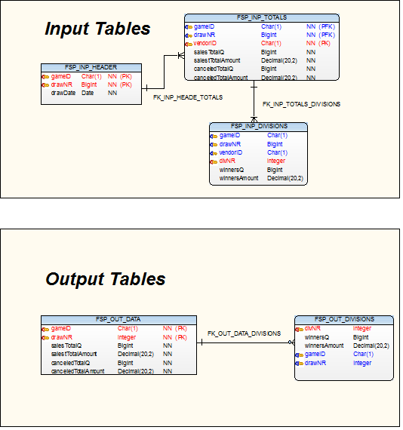
In this diagram, we use the usual symbols that are the used in Information Engineering (a non bifurcated end means one and a bifurcated one means more).
This means:
- One header record (identified by gameID and gameNR) has 1 ore more total records (inheriting the previous primary key plus the vendorID)
- One total record (identified by gameID,gameNR and vendorID) has 1 ore more division records (inheriting the previous primary key plus the divNR).

